1. Select \*

From dept;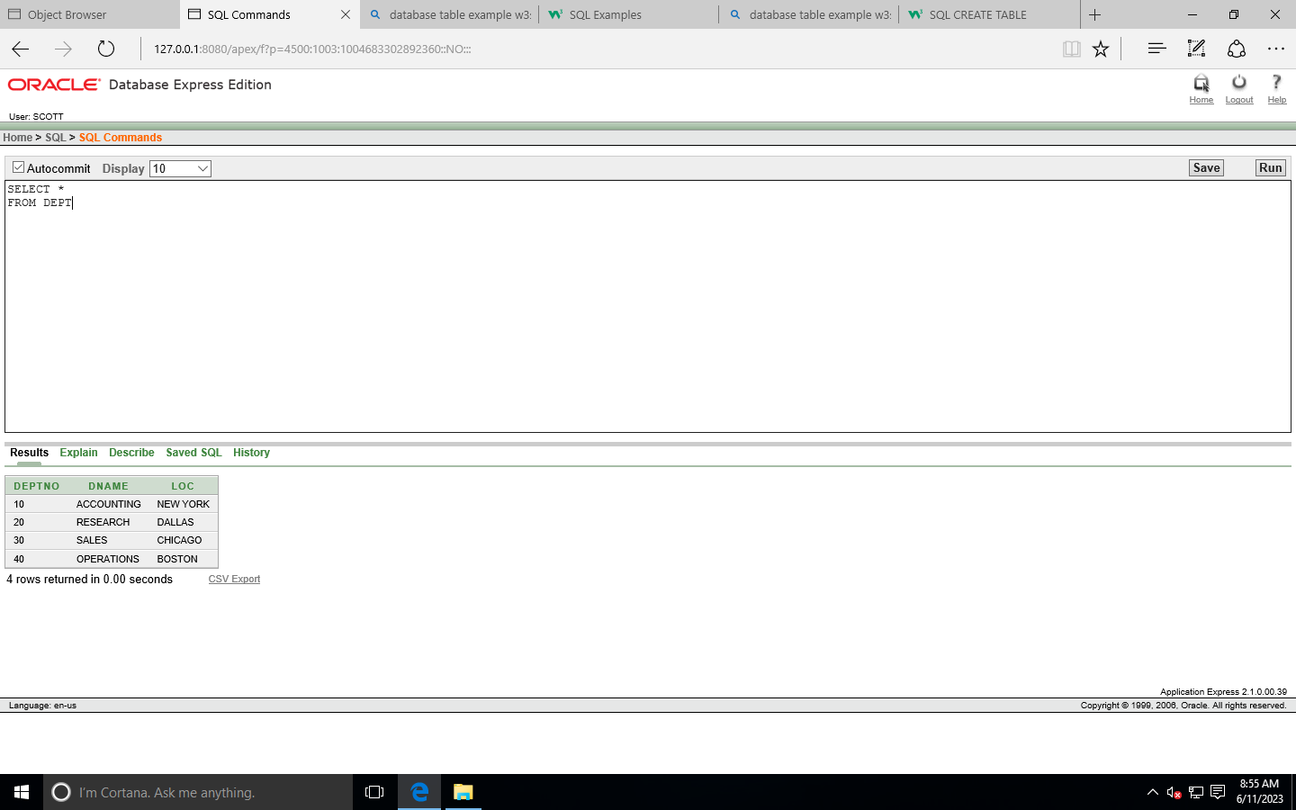

1. Select deptno, loc FROM DEPT

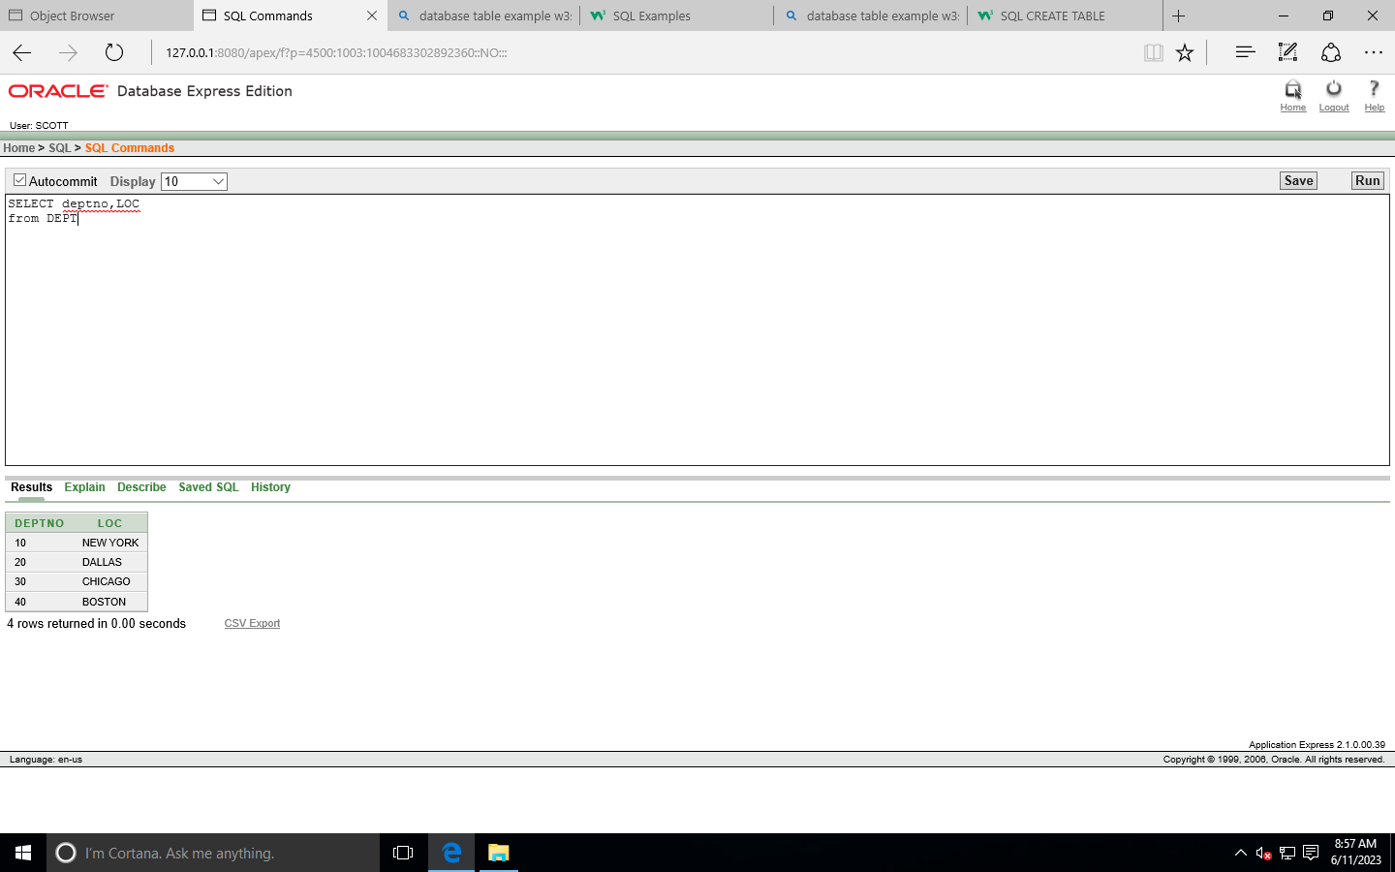

1. SELECT ENAME ,SAL , SAL+1000 FROM EMP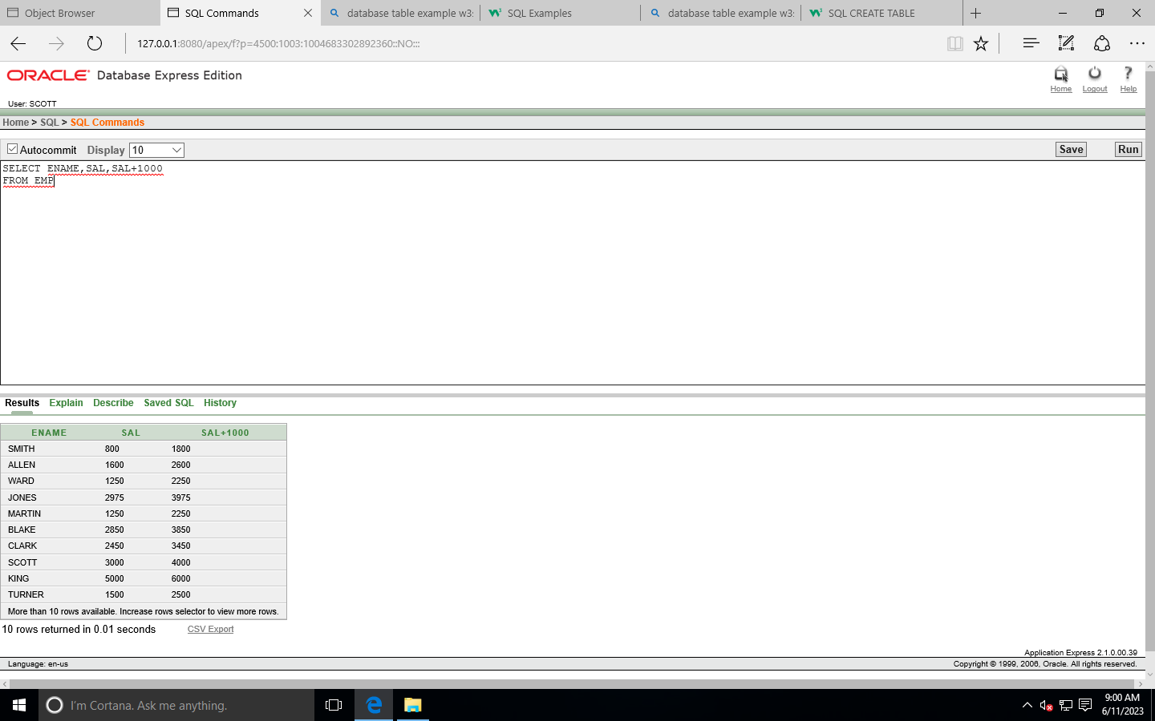
2. SELECT ENMAE ,SAL,12\*SAL+1000 FROM EMP;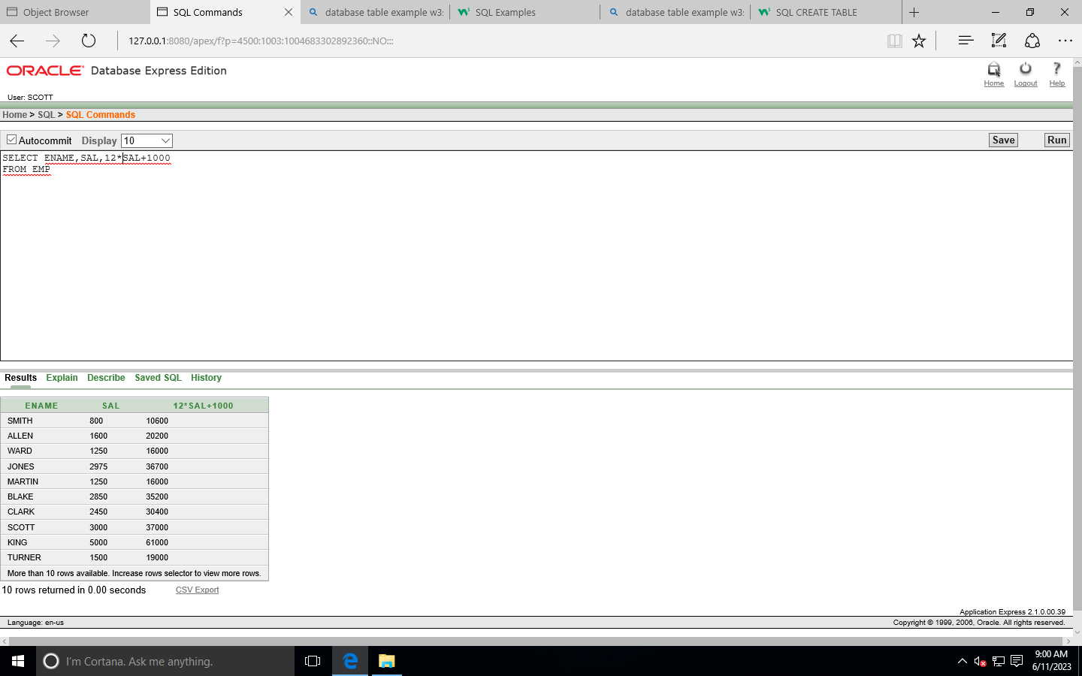
3. SELECT ENMAE ,SAL,12\*(SAL+1000)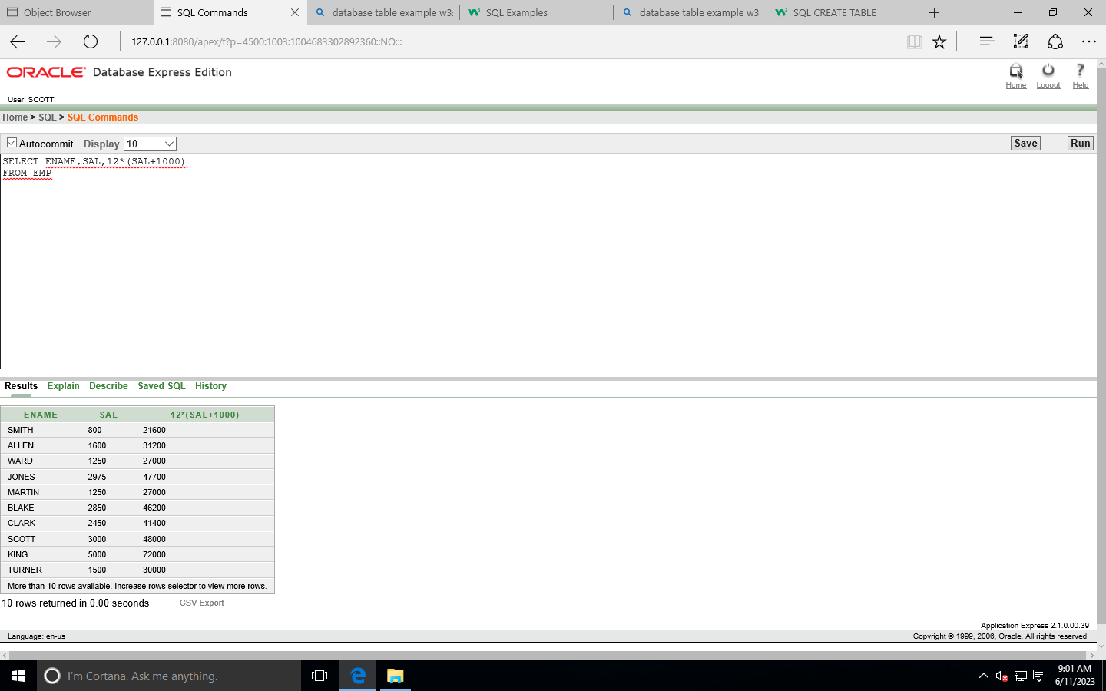 FROM EMP
4. SELECT ENAME , JOB, COMM FROM EMP;

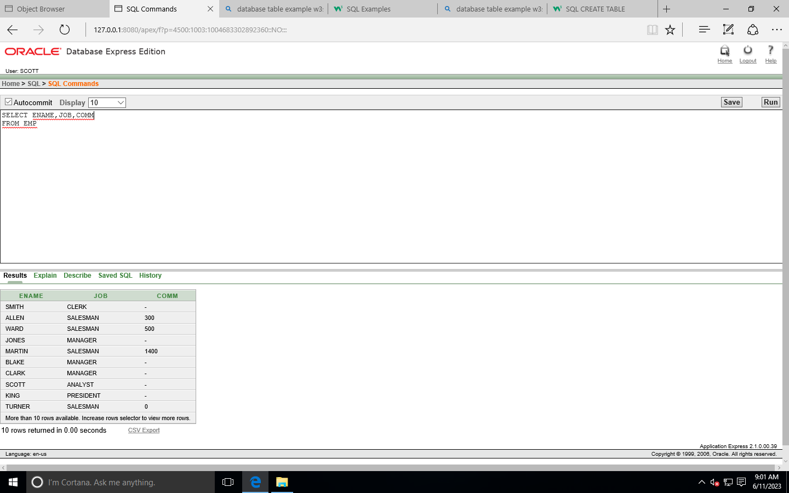

1. SELECT ENMAE , 12\*SAL+COMM FROM EMP WHERE ENAMRE =’KING’;

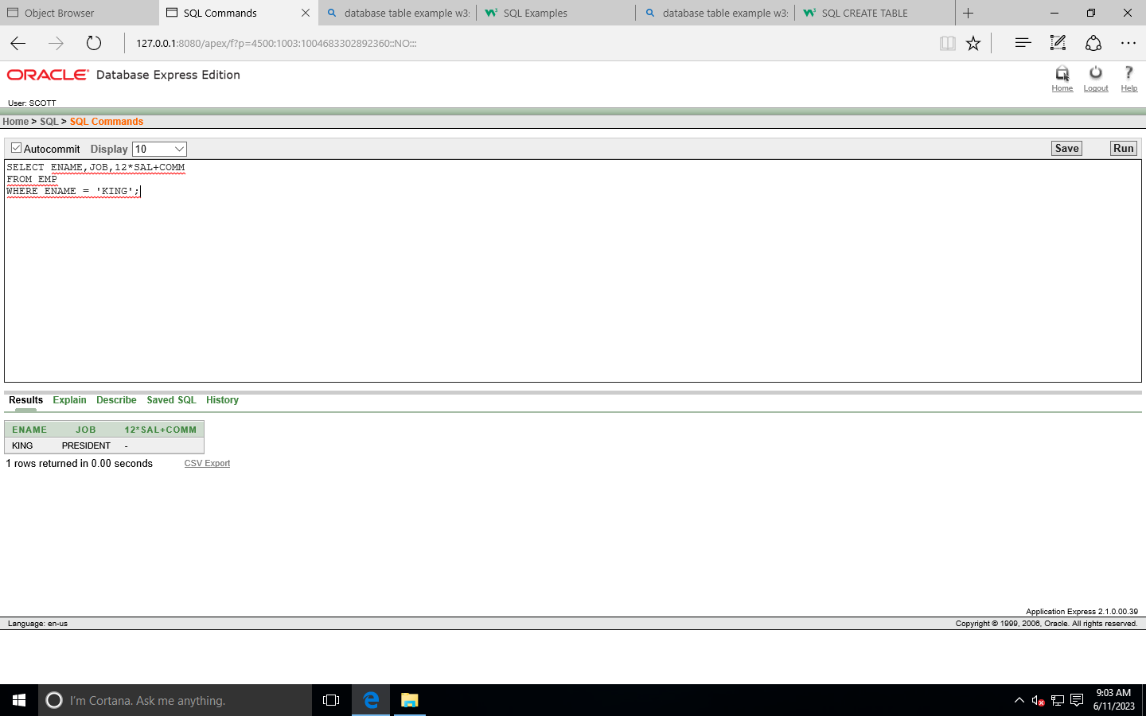

1. SELECT ENAME as NAME , SAL Salary

From emp;

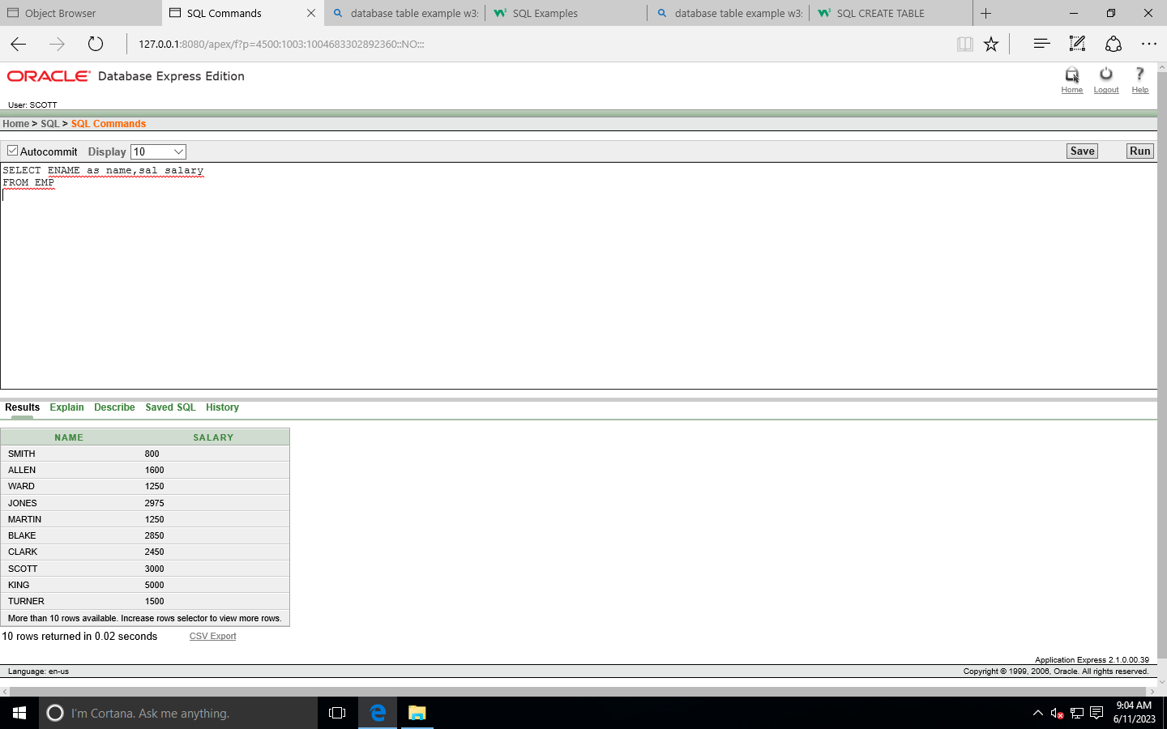

1. SELECT ENAME “NAME”,

SAL\*12”Annual Salary”

From emp;

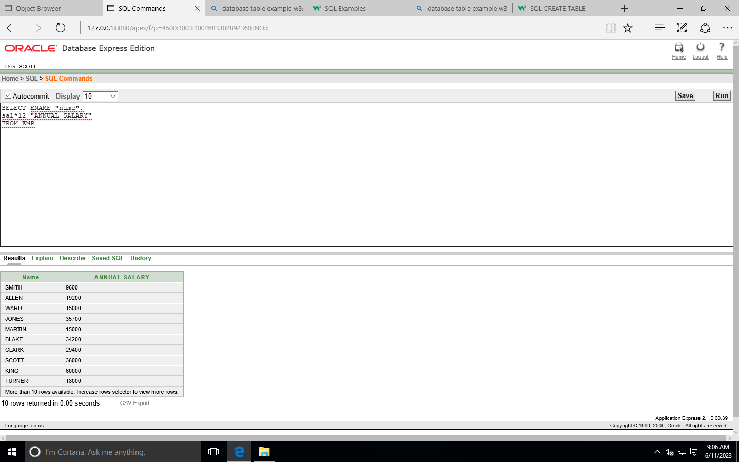

1. Select || job AS “EMPLOYEE”

FROM emp;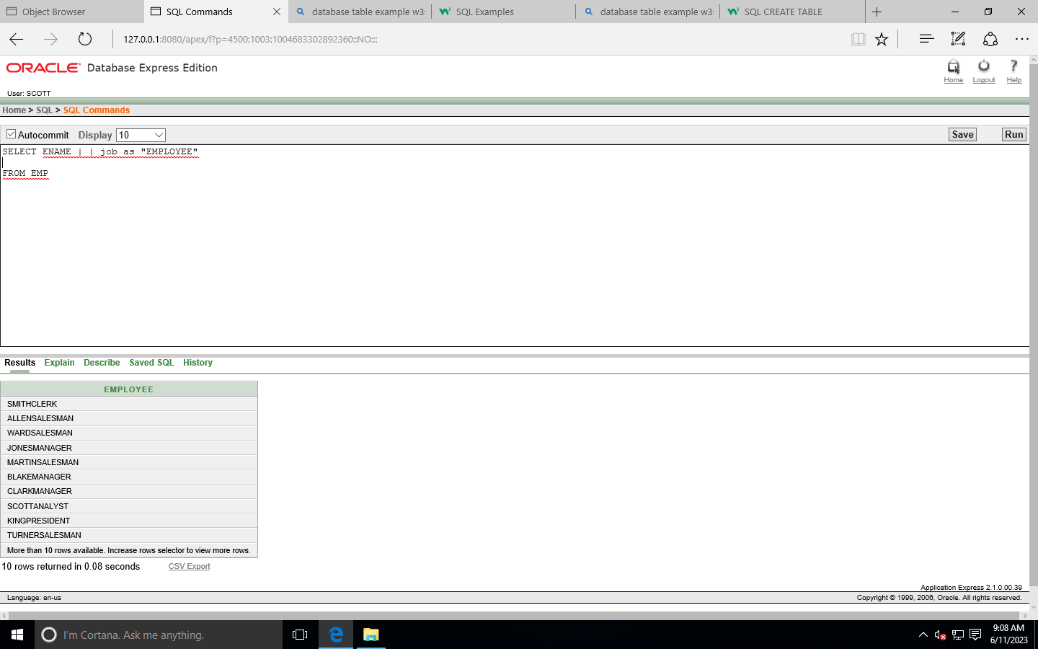

1. SELECT ename ||’ ‘ || ‘ is a ‘ || ‘ ‘ || job

AS “EMPLOYEE DETAILS”

From EMP;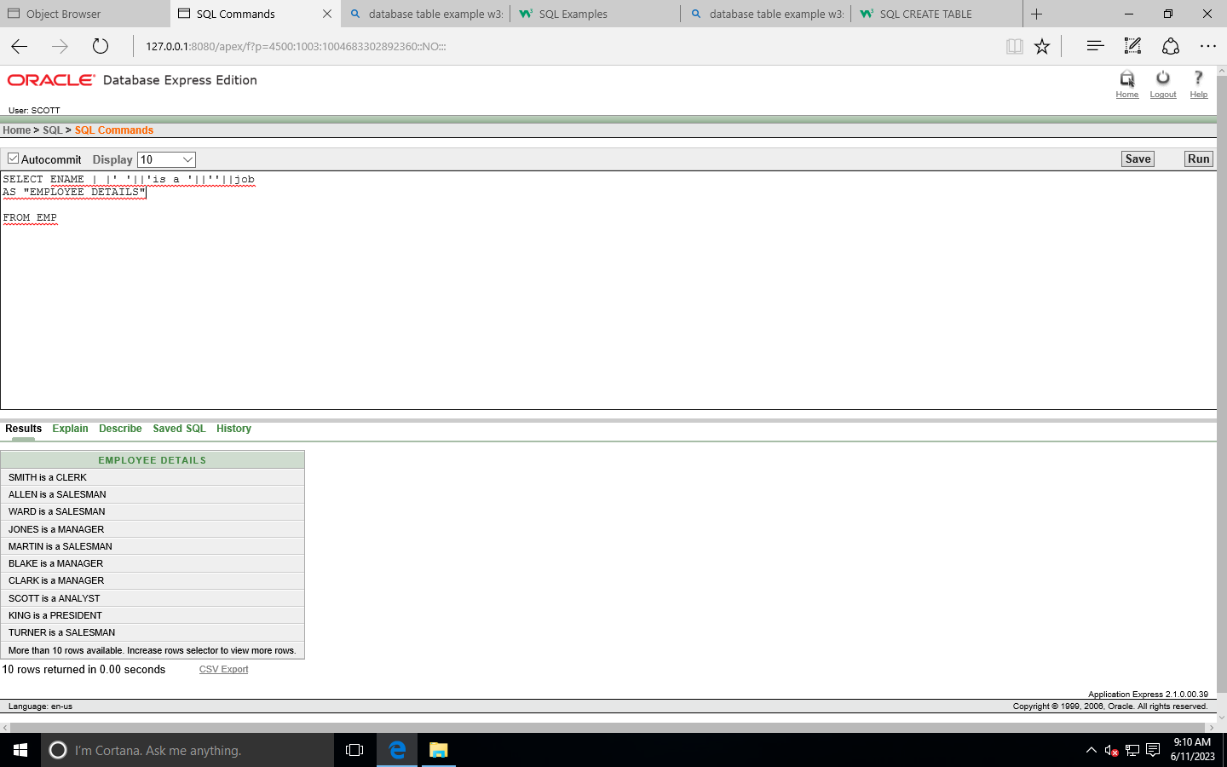

1. SELECT DEPTNO  
     
   FROM EMP;

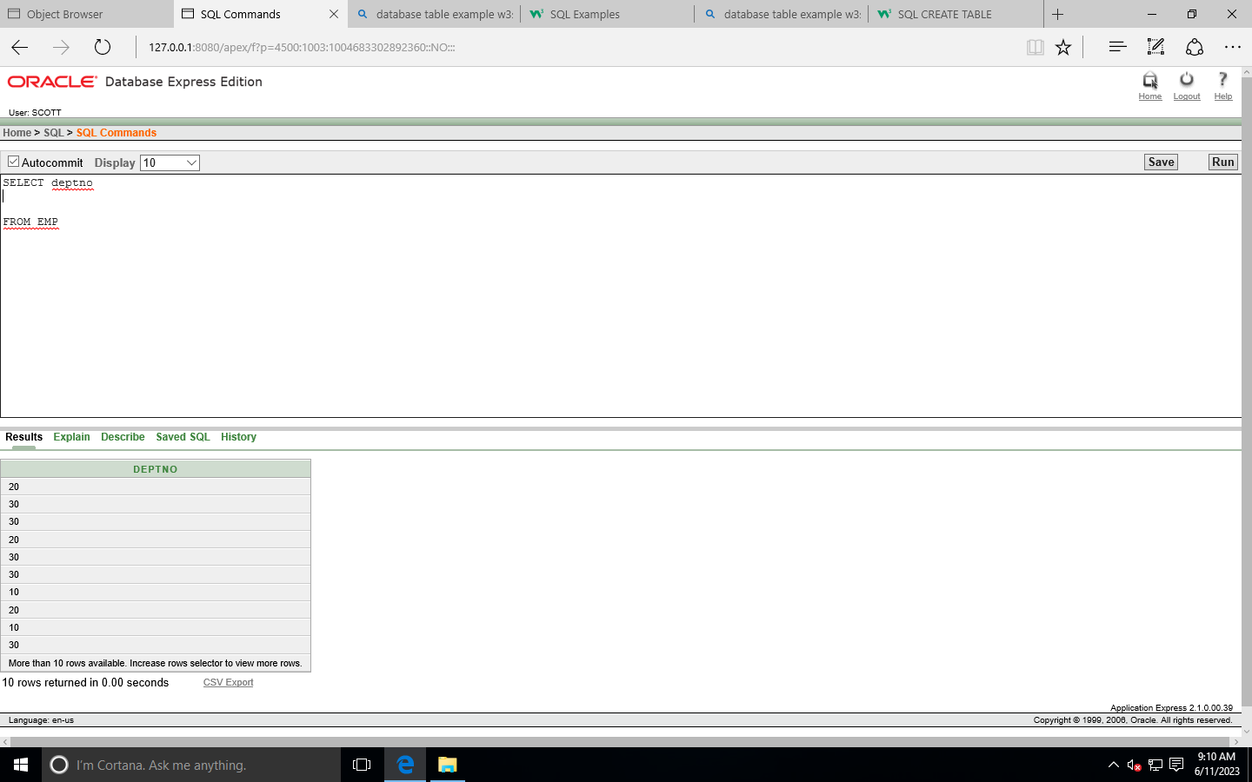

1. SELECT DISTINCt DEPTNO

FROM EMP;

